Results for code :

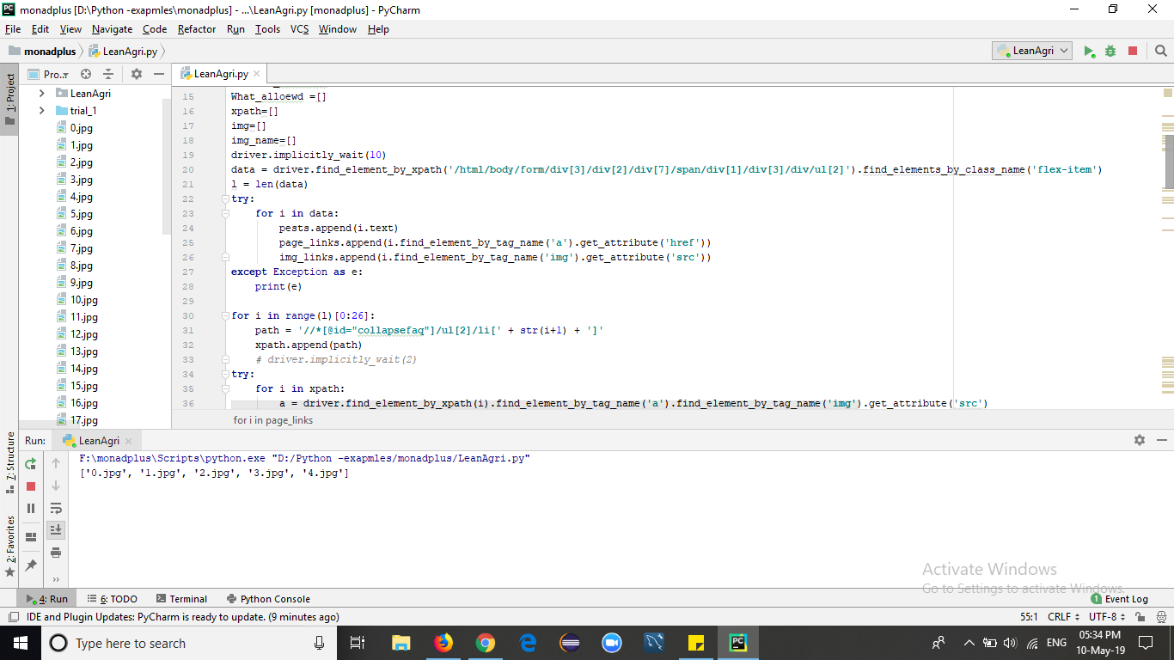

Image 1 : The images for each pest are downloaded and saved in current directory

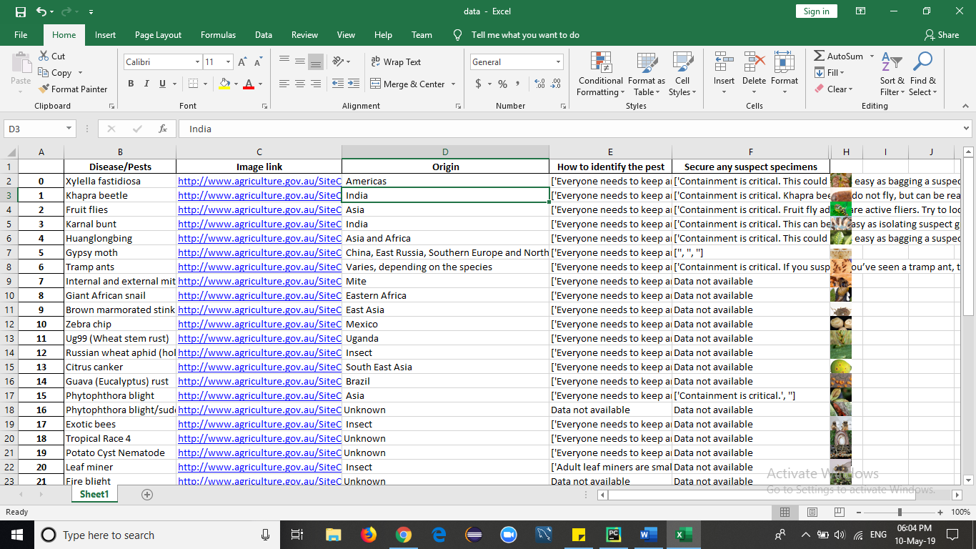

Image 2 : Data saved in excel sheet

Issues :

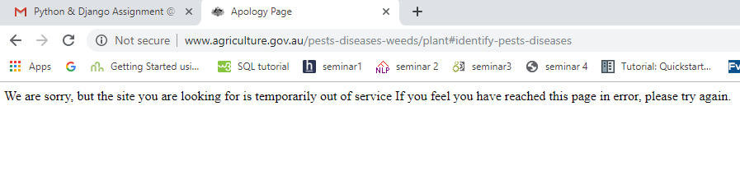

Image 1: As page is under maintenance it was not available sometimes , error shown as page not found

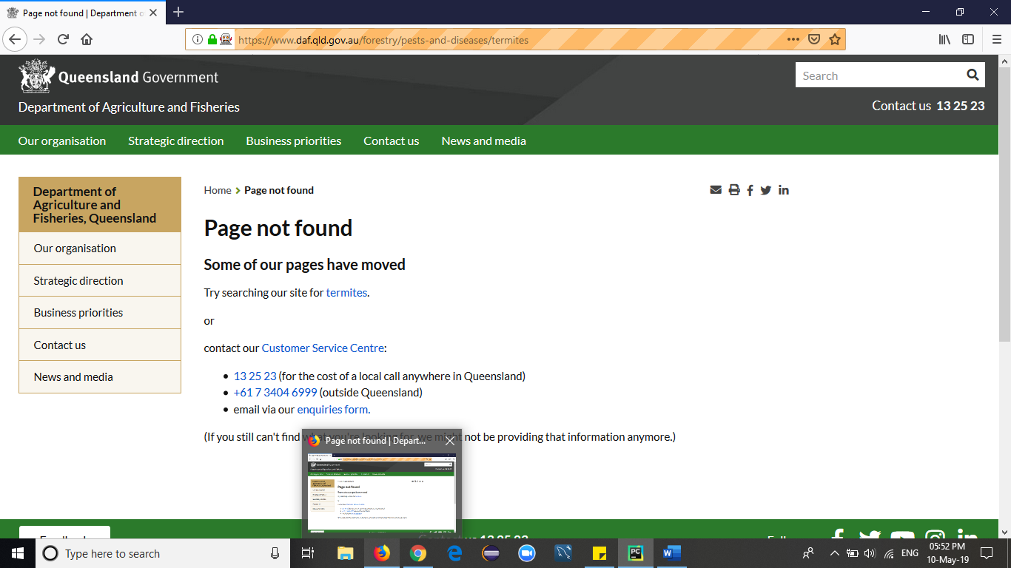

Image 2 : Some pages are not available, thus data for such pages is denoted as ‘not found’ in excel sheet

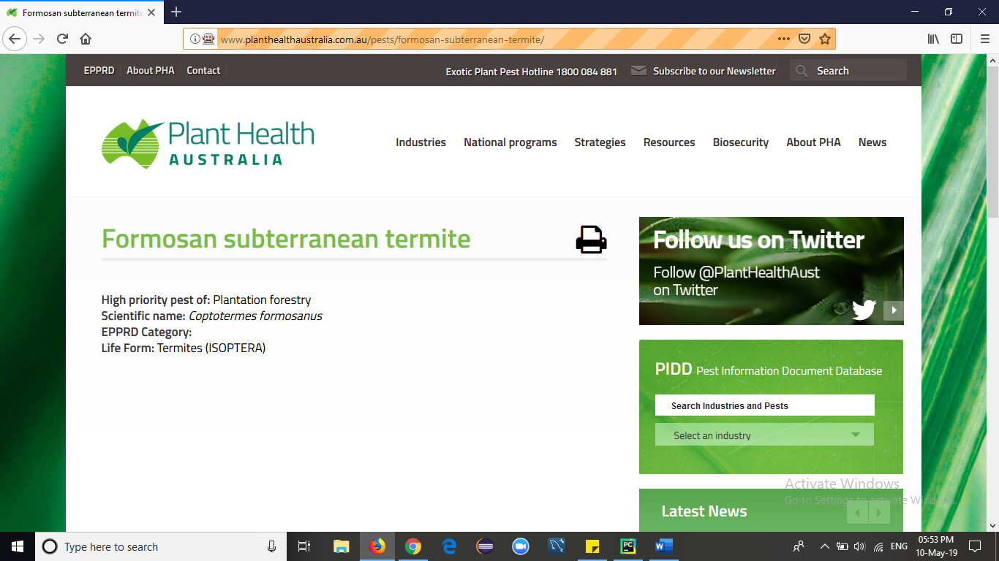

Images 3 : Some pages are different and don’t contain the required information like origin, specimen and how to identify, such data is denoted as ‘data not available ‘ in excel.